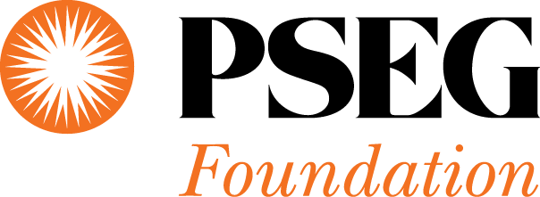

Third Grade Contract for a Healthy Life

Response Form

We are pleased to participate in the Partnership for a Drug–Free New Jersey’s

Third Grade Contract for a Healthy Life Initiative.
We would like to order the coloring and activity book for our students.

You may either fax this completed form to 973-467-2188, or fill out our online form: www.DrugFreeNJ.org/ThirdGradeContract

Name of School:________________________________________________________

Contact: ____________________________________________Title:__________________________

School Address: ________________________________________________________

City: __________________________ State: ____________ Zip: _________________

NJ County: _________________________Telephone number: ______________________________

Email: __________________________________________

Total Number of Coloring/Activity Books Requested: ____________________

Number of Third Grade Classrooms: ______________________

Jeannine Brown

Partnership for a Drug–Free New Jersey

155 Millburn Avenue

Millburn, New Jersey 07041
Phone: 973-467-2100, ext.14
Fax: 973-467-2188

