Sample Press Release

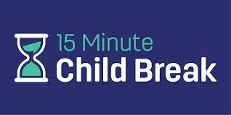 (add your organization logo)
FOR IMMEDIATE RELEASE: (Add Date)
Contact: (Add phone and email)

____________________INSERT TOWN OR ORGANIZATION to Provide Virtual Parenting Substance Abuse Prevention Presentation to the Community

The (NAME OF HOST ORGANIZATION) is sponsoring the Partnership for a Drug-Free New Jersey’s (PDFNJ) 15 Minute Child Break virtual presentation.

Recreational use of marijuana use for adults is now legal in New Jersey, and the ongoing opioid crisis continues to ravage the state. The 15 Minute Child Break multimedia presentation contains up-to-date information on alcohol, marijuana, vaping, opioids and other drugs and provides specific strategies for parents on how to speak with their children about this challenging issue.

“The presentation is based on PDFNJ research finding that parents who talk to their children for at least 15 minutes a day have children who are 67% less likely to experiment with drugs and alcohol,” said Angelo Valente, Executive Director at PDFNJ. “The 15-Minute Child Break is a learning opportunity for parents to understand the signs of use and abuse, current terminology, and trends of use.”

The virtual presentation is available for viewing at (provide link) and using the password (provide password) until (provide date).

(HOST QUOTE)

The PDFNJ also offers a variety of free programs, services and materials. For additional information visit www.drugfreenj.org.

###

