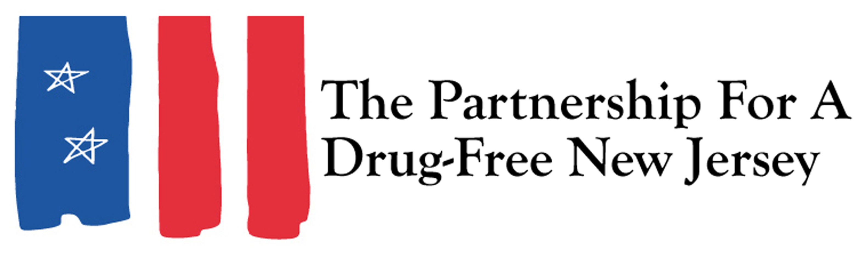
For Immediate Release: March 12, 2015
Contact: Angela Conover, 201-916-1030, conover@drugfreenj.org
Matt Scuteri, 201-916-1032, matt@drugfreenj.org

91% of NJ Residents Want More Information From Their Doctors About Potential Addictive Qualities of the Medications They Are Being Prescribed
TRENTON – The majority of New Jersey residents want the legislature to mandate that their doctor tell them if their prescription medicine is addictive and believe those conversations will reduce the number of individuals who become addicted to pain medications, according to a recent survey effort between Fairleigh Dickinson University’s independent survey research center, PublicMind, and Partnership for a Drug Free New Jersey (PDFNJ).
The study finds that 91% of New Jersey residents agree, the majority (78%) strongly agreeing, that physicians should be legally required to discuss the risk of developing either a physical or psychological dependency on the prescription pain medication with patients prior to prescribing it. Individuals 35 to 59 - the cohort most likely to have been prescribed such a pain medication, are also the most likely to (82%) to strongly agree.
The study also finds that two-thirds (64%) believe that physicians discussing the potential of dependencies with patients will help reduce the number of individuals who ultimately become addicted to the pain medications, while only 30 percent say it will have no impact. “The public is clearly on the side of more rather than less information when a doctor prescribes a potentially addictive substance,” said Krista Jenkins, director of Fairleigh Dickinson PublicMind and professor of political science.
“The abuse of legal painkilling medication has triggered resurgence in the abuse by young people of the illegal versions of these substances, specifically heroin, which costs less and delivers a stronger high. We’re seeing a greater number of addictions to heroin as a result of prescription painkillers,” explained Angelo M. Valente, Executive Director of PDFNJ.
“The rise in the use and abuse of prescription drugs and heroin has reached epidemic proportions in New Jersey, spreading the dangerous disease of addiction and taking the lives of its victims. We have a shared responsibility to take action and to protect our youth from succumbing to this disease,” said Senator Joseph Vitale, D-Middlesex.
“New Jersey residents understand the key conversation between patient and provider can be lifesaving,” said Elaine Pozycki, Co-Chair of PDFNJ. She explained, “These conversations can help patients understand the risks associated with opiate based prescription drugs, as well as the need to be aware of signs and symptoms if a dependency begins. This conversation between a patient and the practitioner is the first line of defense.”
Senate Bill 2366, one of the measures in the 21 bill package introduced by Senate Health, Human Services and Senior Citizens Committee Chairman Joseph F. Vitale to tackle the heroin and prescription drug epidemic that is occurring across the state, requires practitioners to have a conversation with their patient about the risks of developing a physical or psychological dependence before prescribing. The measure passed the Senate in December with a vote of 36-1 and is now waiting to be introduced in the Assembly.
“Mandated conversations between the doctor and patient can mean the difference between living a happy and healthy life and embarking on a long and sometimes deadly path of substance abuse,” Pozycki explained.
According to the NJ Commission of Investigation’s Scenes from an Epidemic, the shared properties of opiate based prescription drugs and the widening abuse of prescription pills has triggered a new and sustained rise in the of heroin abuse in New Jersey.
“The abuse of prescription drugs is a serious public health problem in this country. It has become a precursor to opiate addiction and fueled the heroin epidemic,” said Ocean County Prosecutor Joseph Coronato. “We have seen firsthand in Ocean County its impact in leading to an overdose crisis. It is imperative that we raise awareness and take steps to curb the consequences associated with abuse of prescription medications.”
Data from the Centers for Disease Control and Prevention (CDC) finds that the prescribing of opioids by clinicians has increased threefold in the last 20 years. According to the CDC, health care providers wrote 259 million prescriptions for painkillers in 2012, enough for every American adult to have a bottle of pills and each day, 46 people die from an overdose of prescription painkillers in the United States. CDC Director Tom Frieden, M.D., M.P.H. noted, “addressing prescription opioid abuse by changing prescribing is likely to prevent heroin use in the long term.”
"As primary care providers it is imperative for us to seek and implement firm and scientific guidelines to thwart this epidemic of prescription drug abuse," explained Dr. Shuvendu Sen, Associate Program Director, Raritan Bay Medical Center.
“Today, the number of people who die from prescription opioids exceeds the number of those who die from heroin and cocaine, combined,” noted Angelo M. Valente, executive director of PDFNJ.
"Any legislation that will help curtail the epidemic this state now faces, in terms of prescription drug abuse, is viewed as a positive occurrence. Each day Summit Behavioral Health faces this crisis head on with the clients we serve. Mandating discussion will go a long way in educating the public to the dangers associated with certain medications and empower patients to make better more informed choices when it comes to their healthcare," explained Thomas D. Allen Jr., CEO/President of Summit Behavioral Health.

Recently, the American Academy of Neurology released a statement determining that the risks of powerful narcotic painkillers outweigh their benefits for treating chronic headaches, low back pain and fibromyalgia, noting the drugs can cause serious side effects, overdose, addiction and death and that research shows that 50 percent of patients who took opioids for at least three months are still on them five years later.
“We must support and improve access to prevention, treatment, education and recovery efforts for parents and families from the very first point of contact, often times with a physician, so we can reverse the rapid trend of opiate-related addiction and deaths plaguing our state,” Vitale continued. “I commend the Partnership for a Drug-Free New Jersey for their steadfast commitment and determination to preventing more children and families from falling victim to substance abuse. Their creativity in reaching our youth and families through public awareness campaigns, in schools, and within the community is helping inspire many citizens of New Jersey to fight the battle against substance abuse.”
“As part of a comprehensive prevention strategy, we should address the issue of substance abuse through the discussion envisioned in S2366. This discussion is about understanding the risks to some of the most potent drugs available through a prescription as well as discussing potential alternatives. Patients should have this awareness so that they can take more responsibility in the choices they make,” concluded Pozycki.

Methodology
The most recent survey by Fairleigh Dickinson University’s PublicMind was conducted by telephone from February 23 through March 1 using a randomly selected sample of 901 adults in New Jersey. One can be 95 percent confident that the error attributable to sampling has a range of +/- 3.3 percentage points. The margin of error for subgroups is larger and varies by the size of that subgroup. Survey results are also subject to non-sampling error. This kind of error, which cannot be measured, arises from a number of factors including, but not limited to, non-response (eligible individuals refusing to be interviewed), question wording, the order in which questions are asked, and variations among interviewers.
PublicMind interviews are conducted by Opinion America of Cedar Knolls, NJ, with professionally trained interviewers using a CATI (Computer Assisted Telephone Interviewing) system. Random selection is achieved by computerized random-digit dialing. This technique gives every person with a landline phone number (including those with unlisted numbers) an equal chance of being selected.
Landline households are supplemented with a separate, randomly selected sample of cell-phone respondents interviewed in the same time frame. The total combined sample is mathematically weighted to match known demographics of age, race and gender.
The sample was purchased from Marketing Systems Group and the research was funded by Fairleigh Dickinson University and the Partnership for a Drug New Jersey.

