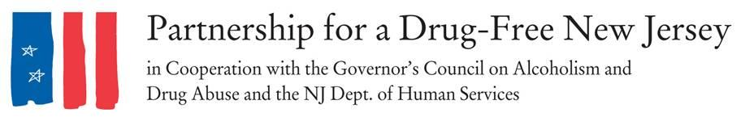
Contact:
Angela Conover, 201-916-1030, conover@drugfreenj.org
David Philemon, 973-467-2100, ext. 24 media@drugfreenj.org
****Press Release****
Over 2,000 New Jerseyans Took to The Streets to Knock Out Opiate Abuse on October 6th
INSERT LOCAL TOWN -- Today, throughout New Jersey thousands of moms, dads, prevention and treatment professionals, students and concerned citizens are taking to the streets to raise awareness about the opiate abuse epidemic impacting our state. INSERT LOCAL INFORMAITON ON OUTREACH. The outreach efforts of volunteers are a result of the October 6, 2016 Knock Out Opiate Abuse Day, an awareness mobilization effort with a dual focus: educating physicians and raising awareness among New Jersey citizens and families. It is designed to bring attention of the opioid abuse epidemic facing New Jersey and the steps they can take to stem the epidemic.
Knock Out Opiate Abuse Day is a project of the Partnership for a Drug-Free New Jersey, in cooperation with the Governor’s Council on Alcoholism and Drug Abuse, the New Jersey Department of Human Services, Division of Addiction Services, and the Coalition for a Safe and Healthy Morris, with thousands of volunteers across the state. INSERT LOCAL INFORMATION
INSERT LOCAL QUOTE
“Knock Out Opiate Abuse Day is an opportunity to engage New Jersey's medical community and families about safe prescribing and non-addictive alternatives to acute and chronic pain. We need to educate all residents and all prescribers with the most current research and protocols that if implemented will save lives and protect families,” explained Angelo M. Valente, Executive Director of the Partnership for a Drug-Free New Jersey.
Valente explained that teams of volunteers across the state visited physician and dental offices in their community to share the CDC Guidelines for prescribing. Volunteers will encourage prescribers to discuss the dangers of opioids when they are prescribed, including the risk of dependency and possible alternatives that may exist, encourage prescribers to implement CDC Guidelines in their own practice and provide information on local organizations and resources focusing the opioid abuse epidemic for physicians to share with their patients.

Valente noted in neighborhoods throughout New Jersey, students, scouts, and concerned families, blanketed their community with “Door Knocker” hang tags for the front doors of local homes. These door knob signs contain an opioid abuse prevention public service announcement with information on the link between prescribed opiates and heroin abuse.

“With the epidemic levels of opiate abuse impacting our state, the time to educate and raise awareness is now,” concluded Valente.

According to the CDC, opioid pain relievers that are abused were most often obtained via prescription from physicians and since 2000, the rate of deaths from drug overdoses has increased 137%, including a 200% increase in the rate of overdose deaths involving opioids; and, users of prescription drugs are 40 times more likely to use heroin. According to the American Academy of Pediatrics legitimate opioid use before high school graduation is independently associated with a 33% increase in the risk of future opioid misuse after high school. This association is concentrated among individuals who have little to no history of drug use and, as well, strong disapproval of illegal drug use at baseline. Use of prescribed opioids before the 12th grade is independently associated with future opioid misuse among patients with little drug experience and who disapprove of illegal drug use.
###
Interview and photo opportunities to speak to volunteers regarding their outreach are available.

