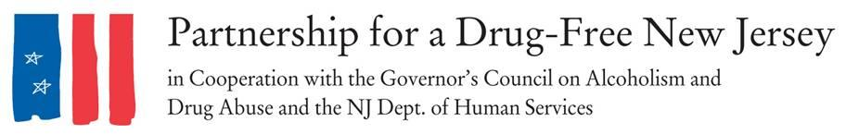
FOR IMMEDIATE RELEASE: INSERT DATE, 2017
Contacts: Matt Birchenough, 201-916-1032, media@drugfreenj.org

***MEDIA ADVISORY***
Volunteers to Spread Awareness of Opioid Epidemic
on Knock Out Opioid Abuse Day
WHAT: On October 6, New Jersey legislators, concerned citizens of INSERT LOCAL TOWN/COUNTY, impacted families and substance abuse professionals will lead an effort to raise awareness about the opioid abuse epidemic impacting our state in the second annual Knock Out Opioid Abuse Day.
The statewide single-day initiative will mobilize volunteers to raise awareness of the potential for dependency on prescribed pain medicine and its link to heroin abuse rates in our state. The effort will have a dual focus: educating physicians and raising awareness among New Jersey residents and families.
Knock Out Opioid Abuse Day is a project of the Partnership for a Drug-Free New Jersey, in cooperation with the Governor’s Council on Alcoholism and Drug Abuse; the New Jersey Department of Human Services, Division of Addiction Services; and the Community Coalition for a Safe and Healthy Morris, with help from thousands of volunteers across the state.
Engaging Physicians
Teams of volunteers across the state will visit physician and dental offices in their community, equipped with information including a door hanger PSA and a copy of the Centers for Disease Control and Prevention (CDC) guidelines for prescribing. Focus will be placed on the following action steps:
- Encouraging prescribers to discuss the dangers of opioids when they are prescribed, including the risk of dependency and possible alternatives that might exist
- Sharing copies of the CDC prescribing guidelines to each prescriber visited and encouraging prescribers to follow the guidelines
- Providing information on local organizations and resources, focusing on the opioid abuse epidemic for physicians to share with their patients
Engaging Families and the Community
Teams of volunteers will be mobilized to place hang tags on the front doors of homes in their communities. These signs will contain an opioid abuse prevention public service announcement with information on the link between prescribed opioids and heroin abuse.
WHY: Opioid pain relievers that are abused were most often obtained via prescription from physicians, and users of prescription drugs are 40 times more likely to use heroin, according to the CDC. More than 33,000 people in the United States died of opioid overdoses in 2015, and the number of such deaths quadrupled from 1999 to 2015.
WHEN: 10 a.m. to 3 p.m. October 6, 2017
WHERE: In communities throughout New Jersey
FOR MORE INFORMATION: Visit drugfreenj.org/knockoutvolunteers. Interview and photo opportunities with volunteers mobilized throughout communities can be arranged.
###
Best known for its statewide anti-drug advertising campaign, the Partnership for a Drug-Free New Jersey is a private not-for-profit coalition of professionals from the communications, corporate and government communities whose collective mission is to reduce demand for illicit drugs in New Jersey through media communication. To date, more than $70 million in broadcast time and print space has been donated to the Partnership’s New Jersey campaign, making it the largest public service advertising campaign in New Jersey’s history. Since its inception, the Partnership has garnered 166 advertising and public relations awards from national, regional and statewide media organizations.

