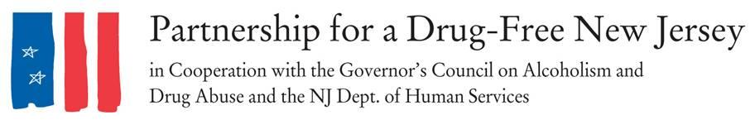

Dear Prescriber [OR PERSONALIZE DOCTOR, DENTIST, NURSE PRACTITIONER],
You are receiving this information as part as Knock Out Opioid Abuse Day in New Jersey.
Last year, more than 3,000 people in New Jersey died of a drug overdose, most of which involved some form of opioid. Nationally, nearly 81,000 of the more than 107,000 total drug overdose deaths in 2021 were related to opioids.
In response to the devastation the opioid epidemic has inflicted upon New Jersey and the nation over the past several years, the Partnership for a Drug-Free New Jersey, in cooperation with the Governor’s Council on Alcoholism and Drug Abuse; the New Jersey Department of Human Services, Division of Addiction Services; and the Community Coalition for a Safe and Healthy Morris established Knock Out Opioid Abuse Day in 2016.
The statewide initiative, which is held October 6 each year, mobilizes volunteers to distribute critical, life-saving information about the potential for dependency on prescribed pain medicine and its link to heroin and fentanyl use. The effort features a dual focus: informing physicians and raising awareness among New Jersey residents and families. Due to the COVID-19 pandemic, all outreach will be conducted virtually again this year.
We appreciate your review of the digital information provided in the Knock Out Opioid Abuse Day Prescriber Resource, which includes the CDC Guideline for Safe Prescribing; New Jersey Treatment/Help Resources; the GCADA “Addiction Doesn’t Discriminate” campaign; information on state legislation requiring healthcare professionals to discuss the addictive qualities of opioids with patients before prescribing and limiting initial prescriptions of opioids to a five-day supply; and the Turn the Tide pamphlet on prescribing opioids for chronic pain. For more information on Knock Out Opioid Abuse Day, visit knockoutday.drugfreenj.org.
The opioid crisis has affected nearly everyone in this country, and it will take a unified effort across all fields and professions to address the crisis. We hope you will take a proactive role to help knock out opioid abuse.

Sincerely,

INSERT GROUP
The Partnership for a Drug-Free New Jersey

