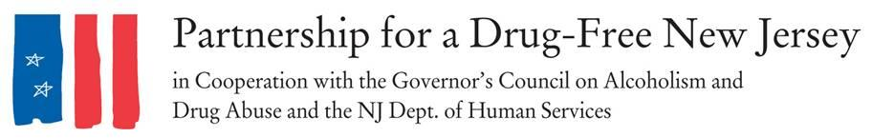
FOR IMMEDIATE RELEASE: Friday, October 6, 2017
Contacts: Matt Birchenough, 201-916-1032, media@drugfreenj.org

More than 6,000 New Jersey Residents Lead Initiative to Knock Out Opioid Abuse
NEW JERSEY -- Friday throughout New Jersey, thousands of parents, prevention and treatment professionals, community leaders, students and concerned residents organized to raise awareness of the opioid epidemic impacting our state on the second annual Knock Out Opioid Abuse Day.
The 6,000-plus volunteers delivered vital information on the dangers posed by prescription opioids and the link to heroin abuse to residents and healthcare professionals in all 21 New Jersey counties. Many communities throughout the state also held special events, including ceremonies and walks, to both commemorate those who have struggled with addiction and to promote prevention methods necessary for stemming the opioid crisis.
An estimated 2,000 people in New Jersey died of an opioid overdose in 2016.
“Knock Out Opioid Abuse Day is an opportunity to engage New Jersey's medical community and families about safe prescribing and non-addictive alternatives to acute and chronic pain,” said Angelo M. Valente, executive director of the Partnership for a Drug-Free New Jersey. “We need to educate all residents and all prescribers with the most current research and protocols that if implemented will save lives and protect families. Today, volunteers throughout the state helped us take a big step in providing the public with this vital information.”
In its second year, Knock Out Opioid Abuse Day increases understanding of the opioid crisis through a mobilization effort with a dual focus: educating physicians and raising awareness among New Jersey citizens and families. The New Jersey Senate and General Assembly responded following the first event in 2016 by unanimously approving joint legislation designating October 6 in perpetuity as Knock Out Opioid Abuse Day in New Jersey.
Knock Out Opioid Abuse Day is a project of the Partnership for a Drug-Free New Jersey, in cooperation with the Governor’s Council on Alcoholism and Drug Abuse; the New Jersey Department of Human Services, Division of Addiction Services; and the Community Coalition for a Safe and Healthy Morris, with help from thousands of volunteers across the state.
Teams of volunteers across the state visited physician and dental offices in their community to share the Centers for Disease Control and Prevention (CDC) guidelines for prescribing. Volunteers urged prescribers to follow the guidelines in their own practice and provided information about local organizations and resources physicians could share with their patients. They also encouraged prescribers to discuss the dangers of opioids when they are prescribed, including the risk of dependency and possible alternatives that might exist.
Groups of volunteers also canvassed neighborhoods throughout New Jersey, placing informative door hangers on the front doors of homes in their communities. These signs contained an opioid abuse prevention public service announcement with information on the link between prescribed opioids and heroin abuse.
“This is an epidemic that affects every community, no matter what the socioeconomic situation may be,” Valente said. “With opioid abuse impacting our state at an epidemic level, the time to educate and raise awareness is now.”
Opioid pain relievers that are abused were most often obtained via prescription from physicians, and users of prescription drugs are 40 times more likely to use heroin, according to the CDC. Meanwhile, legitimate opioid use before high school graduation is independently associated with a 33 percent increase in the risk of future opioid misuse after high school, according to the American Academy of Pediatrics.
Interview and photo opportunities with volunteers regarding their outreach are available upon request.
###
Best known for its statewide anti-drug advertising campaign, the Partnership for a Drug-Free New Jersey is a private not-for-profit coalition of professionals from the communications, corporate and government communities whose collective mission is to reduce demand for illicit drugs in New Jersey through media communication. To date, more than $70 million in broadcast time and print space has been donated to the Partnership’s New Jersey campaign, making it the largest public service advertising campaign in New Jersey’s history. Since its inception, the Partnership has garnered 166 advertising and public relations awards from national, regional and statewide media organizations.

