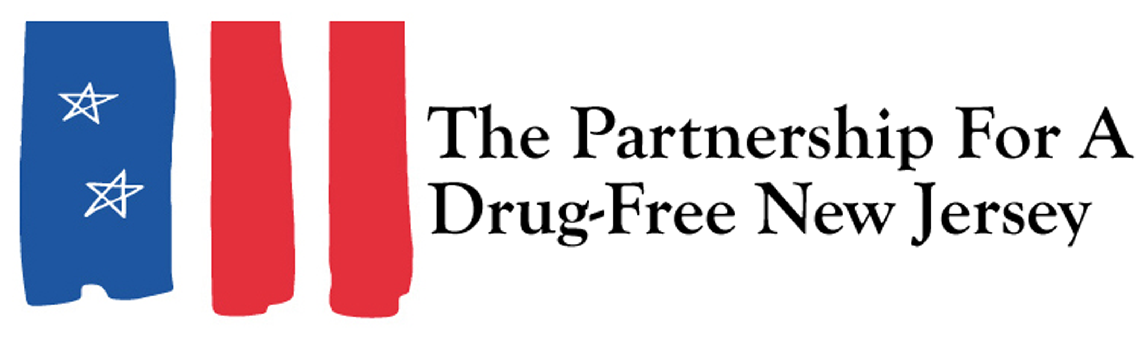
Thank you for your participation in Knock Out Opioid Abuse Day. As discussed at the trainings, a few instructions for outreach are below:

Outreach to Physicians:
- Please be courteous and professional, and keep in mind that prescribers are our partners in developing solutions to address this epidemic.
- Share the Knock Out Opioid Abuse Day Prescriber Resource with prescribers, which includes the CDC Guideline for Safe Prescribing, NJ Treatment/Help Resources and the GCADA Addiction Doesn’t Discriminate campaign. Also share the “Ask Questions Before Taking Opioids” patient palm cards.
- You may make an appointment to speak to a prescriber in your community. If you do, please identify yourself and note that you are sharing the CDC Guideline for Safe Prescribing information on safer prescribing. Please see speaking points/stats below.
- If you are unable to make an appointment, please leave the information with the reception desk. Please leave as quickly as possible to not be in any way intrusive to the patients in the waiting area or the office staff.
- Do not take photos of any patient or the waiting room areas. Only take photos of prescribers when the prescriber has agreed to be photographed.
Outreach to Communities:
- Do not knock on doors, simply leave the information on the door knob.
- Do not open any mailbox to leave information.
- Do not take photos of any house number, home, or resident without the resident’s permission.
- Please leave the property as soon as the information is distributed.

Medicine Misuse Information

- The CDC has declared prescription drug abuse a public health epidemic. Every day, 46 people in the U.S. die from a prescription painkiller overdose. Additionally, addiction to prescription pain medication can become a gateway to heroin use, with research showing that 4 out of 5 new heroin users abused prescription pain relievers before turning to heroin.
- Emergency Physicians Monthly: “Emergency physicians should have an open dialogue with patients regarding the risks of opioid analgesics, including addiction, at the time of prescribing. This should happen with every patient because opioid misuse and abuse often starts with a legitimate medical prescription.”
- Abuse Rates among 18-25: July 2015: National opioid abuse rates can be found in this CDC Report that finds Heroin use more than doubled among young adults ages 18–25 in the past decade
- http://www.cdc.gov/vitalsigns/pdf/2015-07-vitalsigns.pdf
- Emerging data on brain development suggests that the brain may not reach full maturity until a person’s early or mid-20s, and therefore substance use disorders might not emerge until young adulthood.
- According to a report released by the Centers for Disease Control and Prevention (CDC), heroin use has increased across the United States among men and women, most age groups, and all income levels.
- The report found that the strongest risk factor for heroin use is prescription opioid abuse and that the greatest increases in heroin abuse have occurred in groups with historically lower rates of heroin use, including women, people with private insurance and higher incomes.
- “Heroin use is increasing at an alarming rate in many parts of society, driven by both the prescription opioid epidemic and cheaper, more available heroin,” said CDC Director Tom Frieden, M.D., M.P.H. According to the CDC, opioid pain relievers that are misused were most often obtained via prescription from physicians.
- 53 percent of prescription painkillers misused are either given by, bought from or taken from a friend or relative.¹
- The New Jersey Office of the Attorney General reported that nearly 4.9 million prescriptions for opioid painkillers were dispensed in the state in 2017.
- In 2016, 11.5 million people aged 12 or older had misused prescription pain relievers during the previous year.¹
- Half of New Jersey principals surveyed said that prescription drugs are abused more than twice that of ecstasy and cocaine by Middle School students. ²
- 30% of New Jersey Middle School students said that using prescription drugs not prescribed to you does not have any real health consequences or have only mild health consequences, but they’re not serious or too long lasting.²
- 47% of parents of New Jersey Middle School students said they know a little or just about nothing about prescription drug abuse. ²
- 23% of New Jersey residents aged 21-30 have abused prescription drugs.²
- In 2016, about 2.5 million young adults aged 18 to 25 and 891,000 adolescents aged 12 to 17 had misused opioids during the previous year. ¹
- In 2016, an estimated 92,000 adolescents aged 12 to 17 and 767,000 of young adults aged 18 to 25 had misused stimulants in the past month.¹
- In 2016, an estimated 121,000 adolescents aged 12 to 17 and 536,000 of young adults aged 18 to 25 had misused tranquilizers in the past month.¹
- Many teens think these drugs are safe because they have legitimate uses, but taking them without a prescription to get high or “self-medicate” can be as dangerous – and addictive – as using street narcotics and other illicit drugs.³
- Next to marijuana, the most common illegal drugs teens are using to get high are prescription medications.⁴
- Teens are abusing prescription drugs because they believe the myth that these drugs provide a medically safe high.⁴
- The majority of teens get prescription drugs easily and for free, often from friends or relatives. ⁴
- Girls are more likely than boys to intentionally abuse prescription drugs to get high. ⁴
- Pain relievers such as OxyContin and Vicodin are the most commonly abused prescription drugs by teens. ⁴
- Adolescents are more likely than young adults to become dependent on prescription medication. ⁴

Sources:
¹SAMHSA, Results from the 2016 National Survey on Drug Use and Health
²Partnership for a Drug-Free New Jersey Center for Prevention
³Partnership for a Drug-Free America Teen Tracking Study
⁴Research Office of National Drug Control Policy: Teens and Prescription Drugs Analysis, February 2007

