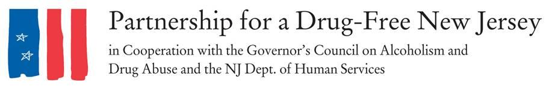

Dear Prescriber [OR PERSONALIZE DOCTOR, DENTIST, NURSE PRACTITIONER],
You are receiving this information as part as Knock Out Opioid Abuse Day in New Jersey.
In 2016, more than 42,000 people in the United States died of an opioid overdose. As stunning and tragic as that figure is, the final death total for 2017 is expected to be even higher, and early data for 2018 indicates a continued rise in overdose deaths.
In response to these statistics and many stories associated with the opioid epidemic that has ravaged New Jersey and the nation over the past decade, the Partnership for a Drug-Free New Jersey, in cooperation with the Governor’s Council on Alcoholism and Drug Abuse; the New Jersey Department of Human Services, Division of Addiction Services; and the Community Coalition for a Safe and Healthy Morris established Knock Out Opioid Abuse Day in 2016.
The statewide single-day initiative, which is held October 6 each year, mobilizes volunteers to distribute critical, life-saving information about the potential for dependency on prescribed pain medicine and its link to heroin use. The effort features a dual focus: informing physicians and raising awareness among New Jersey residents and families.
We appreciate your review of the information provided in the Knock Out Opioid Abuse Day Prescriber Resource, which includes the CDC Guideline for Safe Prescribing; New Jersey Treatment/Help Resources; the GCADA “Addiction Doesn’t Discriminate” campaign; information on state legislation requiring healthcare professionals to discuss the addictive qualities of opioids with patients before prescribing and limiting initial prescriptions of opioids to a five-day supply; and the Turn the Tide pamphlet on prescribing opioids for chronic pain. For more information on Knock Out Opioid Abuse Day, visit drugfreenj.org/knockoutvolunteers.
The opioid crisis has affected nearly everyone in this country, and it will take a unified effort across all fields and professions to address the crisis. We hope you will take a proactive role to help knock out opioid abuse.

Sincerely,

INSERT GROUP
The Partnership for a Drug-Free New Jersey

