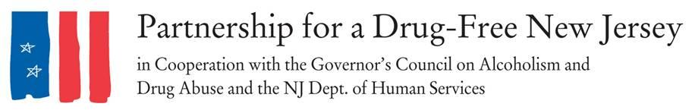
FOR IMMEDIATE RELEASE: INSERT DATE, 2018
Contacts: Matt Birchenough, 201-916-1032, media@drugfreenj.org
ADD LOCAL CONTACT
Email Matt Birchenough at media@drugfreenj.org for any help and with a list of media outlets you plan to send the media advisory to.

***MEDIA ADVISORY***
[TOWN/COUNTY] Volunteers to Spread Awareness of Opioid Epidemic on Knock Out Opioid Abuse Day
WHAT: On October 6, residents of INSERT TOWN/COUNTY will lead an effort to raise awareness of the opioid epidemic impacting our state in the third annual Knock Out Opioid Abuse Day in New Jersey.
The statewide single-day initiative will mobilize volunteers to carry out a mission with a dual focus: informing physicians and raising awareness among New Jersey residents and families about the link between prescription opioids and heroin use.
PROVIDE INFORMATION ON YOUR GROUP’S SPECIFIC EFFORTS
Knock Out Opioid Abuse Day is a project of the Partnership for a Drug-Free New Jersey, in cooperation with the Governor’s Council on Alcoholism and Drug Abuse; the New Jersey Department of Human Services, Division of Addiction Services; and the Community Coalition for a Safe and Healthy Morris, with help from thousands of volunteers across the state.
WHY: In 2016 — the most recent year with complete data — more than 42,000 people in the United States and about 2,000 people in New Jersey lost their lives from an opioid overdose.
WHEN: INSERT TIME OF ACTIVITIES October 6, 2018
WHERE: LOCATION OF ACTIVITIES
FOR MORE INFORMATION: Visit drugfreenj.org/knockoutvolunteers. Interview and photo opportunities with volunteers mobilized throughout communities can be arranged.
INCLUDE CONTACT INFORMATION FOR ORGANIZERS AND WHERE TO FIND INFORMATION ON EVENTS
###
Best known for its statewide substance use prevention advertising campaign, the Partnership for a Drug-Free New Jersey is a private not-for-profit coalition of professionals from the communications, corporate and government communities whose collective mission is to reduce demand for illicit drugs in New Jersey through media communication. To date, more than $100 million in broadcast time and print space has been donated to the Partnership’s New Jersey campaign, making it the largest public service advertising campaign in New Jersey’s history. Since its inception, the Partnership has garnered 174 advertising and public relations awards from national, regional and statewide media organizations.

