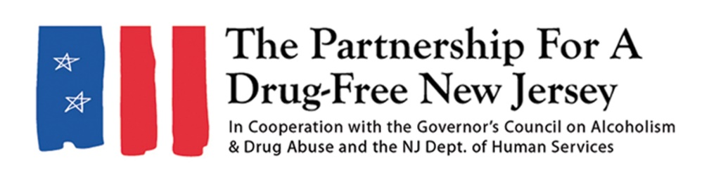Add organization logo
FOR IMMEDIATE RELEASE: Saturday, October 6, 2018
Contact: Matt Birchenough, 201-916-1032, media@drugfreenj.org
Add Local Contact here
[Name of Town] Residents Lead Effort to Knock Out Opioid Abuse
YOUR TOWN — [Residents/members of your group(s)] united to take action against the opioid epidemic impacting New Jersey [Day you held outreach events] as part of the third annual Knock Out Opioid Abuse Day organized by the Partnership for a Drug-Free New Jersey.
Write a sentence or two about what your group did (walked neighborhoods with door hangers, visited doctors’ offices, set up tables at community locations/events)
Include a quote from your volunteer organizer about the importance of Knock Out Opioid Abuse Day/why it’s important to share this information in the community
[YOUR TOWN] was one of many throughout the state that helped spread the word about the dangers of prescription opioids and their link to heroin use on Knock Out Opioid Abuse Day. Participants — which included families, treatment and recovery professionals, law enforcement personnel, county and local government officials, high school students and several other groups and organizations — mobilized in all 21 New Jersey counties, distributing information on the risks of prescription opioids and their link to heroin use to residents, as well as guides on safer prescribing to healthcare professionals.
“Knock Out Opioid Abuse Day is an opportunity for New Jersey residents to take action to help stem the tide of the opioid epidemic impacting our state,” said Angelo Valente, executive director of the Partnership for a Drug-Free New Jersey. “Whether they are providing vital lifesaving information on opioids to neighbors in their communities or guides on safer prescribing to doctors, dentists and other medical professionals, New Jersey residents have stepped up to make this state more informed and better prepared to prevent their friends and families from become addicted to opioids.”
In its third year, Knock Out Opioid Abuse Day increases understanding of the opioid crisis through a mobilization effort with a dual focus: educating physicians and raising awareness among New Jersey citizens and families. The New Jersey Senate and General Assembly has unanimously approved joint legislation permanently designating October 6 as Knock Out Opioid Abuse Day in New Jersey.
Knock Out Opioid Abuse Day is a project of the Partnership for a Drug-Free New Jersey, in cooperation with the Governor’s Council on Alcoholism and Drug Abuse; the New Jersey Department of Human Services, Division of Addiction Services; and the Community Coalition for a Safe and Healthy Morris, with help from thousands of people from across the state.
In 2017, about 49,000 Americans died of an opioid overdose, according to provisional counts by the Centers for Disease Control. That total would represent a 16 percent increase in the number of deaths from 2016. These deaths include those who overdosed on heroin, prescription opioids and synthetic opioids, such as fentanyl.
In New Jersey nearly 2,200 people have died from drug overdoses so far in 2018, a majority of which have involved opioids. New Jersey also has the sixth highest rate of visits to the emergency room due to opioid overdoses.
If you have any more information on your outreach efforts, you can add it here
Include another quote
###
Best known for its statewide substance use prevention advertising campaign, the Partnership for a Drug-Free New Jersey is a private not-for-profit coalition of professionals from the communications, corporate and government communities whose collective mission is to reduce demand for illicit drugs in New Jersey through media communication. To date, more than $100 million in broadcast time and print space has been donated to the Partnership’s New Jersey campaign, making it the largest public service advertising campaign in New Jersey’s history. Since its inception, the Partnership has garnered 174 advertising and public relations awards from national, regional and statewide media organizations.

