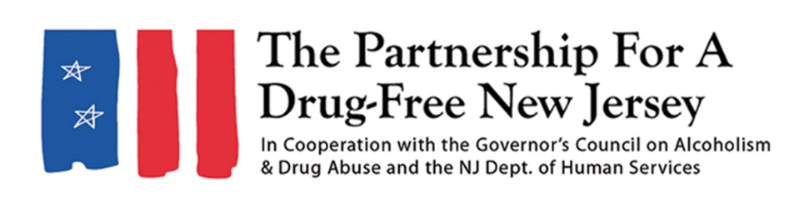
Dear [NAME OF ATHLETIC DIRECTOR],
The opioid crisis continues to take a tragic toll on New Jersey. Last year, more than 3,000 people in the state died of drug overdoses, a majority of which can be attributed to opioids, such as prescription painkillers, heroin and synthetic opioids including fentanyl.
The opioid epidemic has affected people of all backgrounds, regardless of wealth, race, religion or age. However, New Jersey’s youth athletes can be even more susceptible to opioid addiction in large part to the potential of sports injuries and access to prescription painkillers to treat them.
It is vital that we act to help protect youth and high school athletes from the risks of prescription opioids through education and by creating a safe environment to learn and participate in sports. The Partnership for a Drug-Free New Jersey’s Knock Out Opioid Abuse Day is an opportunity to inform all student athletes and their parents about the dangers of opioids and make them aware of the tragic opioid crisis the state and nation are experiencing.
Knock Out Opioid Abuse Day has been held in New Jersey on October 6 each year since 2016. The statewide single-day initiative, organized by the Partnership for a Drug-Free New Jersey and The Community Coalition for a Safe & Healthy Morris, in cooperation with the New Jersey Division of Mental Health and Addiction Services and the Governor’s Council on Alcoholism and Drug Abuse, mobilizes the prevention and treatment communities, community leaders and concerned citizens to raise awareness of the opioid epidemic and the link between prescription painkillers and heroin and fentanyl use.
This year, the Partnership for a Drug-Free New Jersey and participants throughout New Jersey will share important messages about the opioid crisis virtually. We ask that your athletic department and school share information about opioid risks and safety, which will be available at knockoutday.drugfreenj.org.
These messages and information about resources for substance use prevention and treatment can be shared on the district website and to parents and students via email and social media. For more information, contact Matt Birchenough at matt@drugfreenj.org.

Sincerely,

_____________________

