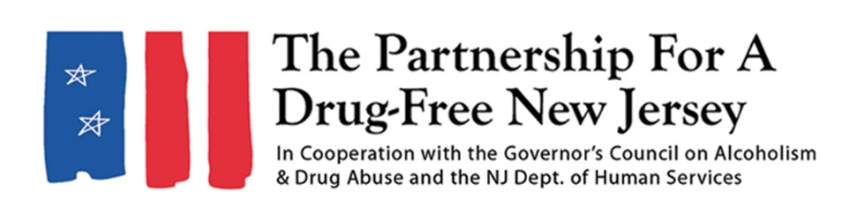
PLEASE CHECK WITH YOUR PUBLICATION FOR WORD LIMITS BEFORE SUBMITTING A LETTER TO THE EDITOR
Letter to the editor
Last year, nearly 3,000 people died of a drug overdose in New Jersey. We have made progress fighting the opioid epidemic responsible for most of these deaths, but it’s clear there is still so much work to do.
In an effort to bring further awareness to this crisis, thousands of New Jersey residents will participate in Knock Out Opioid Abuse Day on October 6 and throughout the month of October. As part of the statewide initiative, residents will share information about the potential for dependency on prescribed opioids and their link to heroin use, as well as the dangers of synthetic opioids like fentanyl, which now account for a majority of the opioid deaths in New Jersey and the nation.
In its eighth year, Knock Out Opioid Abuse Day will take place almost exclusively in a virtual format on social media, organization websites and through the Partnership for a Drug-Free New Jersey’s Knock Out Opioid Abuse Day Learning Series. However, many organizations will also provide educational materials at community events throughout the state.
Knock Out Opioid Abuse Day is a project of the Partnership for a Drug-Free New Jersey, in cooperation with the Governor’s Council on Alcoholism and Drug Abuse; the New Jersey Department of Human Services, Division of Addiction Services; and the Community Coalition for a Safe and Healthy Morris.
The opioid epidemic has affected us all in some way. The good news is that each of us can help to prevent opioid abuse in our communities. Knock Out Opioid Abuse Day is a perfect opportunity to be a part of the solution to this crisis. Please join us on October 6.
Visit knockoutday.drugfreenj.org for more information and to sign up to participate.

