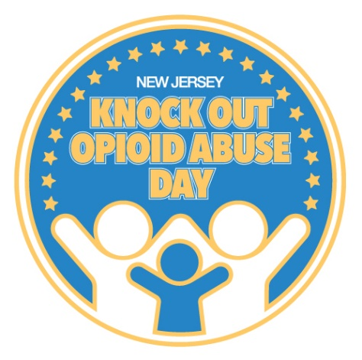

Dear Rabbi,
As the Jewish New Year of Rosh Hashana is upon this week, I wanted to reach out to you and wish you a Happy New Year. I know that the high holidays are a time when much of your congregation comes together to worship and pray for a peaceful, prosperous and healthy New Year. I am writing to you to appeal to a cause that is very dire during these stressful times.
I know that the pandemic has caused so much hardship, stress and uncertainty to everyone’s lives. For those suffering from substance use disorder, this time of isolation and stress has been even more difficult. Drug overdose deaths have risen dramatically during the pandemic. In 2019, more than 3,000 people in New Jersey died of a drug overdose, a majority of which involved some form of opioid. The pandemic is making the opioid crisis even more dire with overdose deaths up 42 percent in May.
Governor Murphy officially designated October 6 as Knock Out Opioid Abuse Day in New Jersey, a statewide project that is created by the Partnership for a Drug-Free New Jersey (PDFNJ); The Governor’s Council on Alcoholism and Drug Abuse; the New Jersey Department of Human Services, Division of Addiction Services; and the Community Coalition for a Safe and Healthy Morris, with help from partners across the state.
With about three weeks to go until the 5th annual Knock Out Day, I wanted writing to you to ask that as you think about the many things that you might be discussing with your congregation during these high holy days, that you may consider brining awareness to this important cause. I have attached a sample flyer of some talking points that may be useful.
Again Happy New Year.

