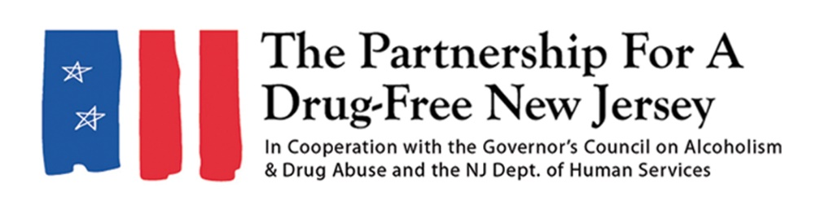Add organization logo
FOR IMMEDIATE RELEASE: DATE
Contact: Matt Birchenough, matt@drugfreenj.org
Add Local Contact here
[Name of Town/School/Group/etc.] [Residents/Students/Members] Lead Effort to Knock Out Opioid Abuse
YOUR TOWN — [Residents/members of your group(s)] helped fight the opioid epidemic impacting New Jersey [Day you held outreach events] as part of the eighth annual Knock Out Opioid Abuse Day organized by the Partnership for a Drug-Free New Jersey (PDFNJ).
Write a sentence or two about what your group did (social media, virtual events, etc.).
Include a quote from your volunteer organizer about the importance of Knock Out Opioid Abuse Day/why it’s important to share this information in the community
[YOUR TOWN/SCHOOL/GROUP/etc.] was one of many throughout the state that helped spread the word about the risks of prescription opioids and their link to heroin use, as well as the dangers of fentanyl, on Knock Out Opioid Abuse Day. Participants — which included families, treatment and recovery professionals, law enforcement personnel, county and local government officials, high school students and several other groups and organizations — mobilized in all 21 New Jersey counties.
“Knock Out Opioid Abuse Day gives everyday New Jersey residents a chance to fight the opioid epidemic and help share potentially lifesaving information in their community,” said Angelo Valente, executive director of the Partnership for a Drug-Free New Jersey. “PDFNJ is grateful to have so many dedicated participants around the state, who have shared this information with their friends and neighbors to educate them about the risks associated with opioids.”
In its eighth year, the goal of Knock Out Opioid Abuse Day is to help increase residents’ understanding of the opioid crisis through a mobilization effort with a dual focus: educating physicians and raising awareness among New Jersey citizens and families. The New Jersey Senate and General Assembly have unanimously approved joint legislation permanently designating October 6 as Knock Out Opioid Abuse Day in New Jersey.
Knock Out Opioid Abuse Day is a project of the Partnership for a Drug-Free New Jersey, in cooperation with the Governor’s Council on Alcoholism and Drug Abuse; the New Jersey Department of Human Services, Division of Addiction Services; and the Community Coalition for a Safe and Healthy Morris, with help from thousands of people from across the state.
In 2022, nearly 3,000 people in New Jersey died of a drug overdose, a majority of which involved some form of opioid. These deaths include those who overdosed on heroin, prescription opioids and synthetic opioids, such as fentanyl.
If you have any more information on your outreach efforts, you can add it here
Include another quote
###
Best known for its statewide substance use prevention advertising campaign, the Partnership for a Drug-Free New Jersey is a private not-for-profit coalition of professionals from the communications, corporate and government communities whose collective mission is to reduce demand for illicit drugs in New Jersey through media communication. To date, more than $200 million in broadcast time and print space has been donated to the Partnership’s New Jersey campaign, making it the largest public service advertising campaign in New Jersey’s history. Since its inception, the Partnership has garnered 211 advertising and public relations awards from national, regional and statewide media organizations.

