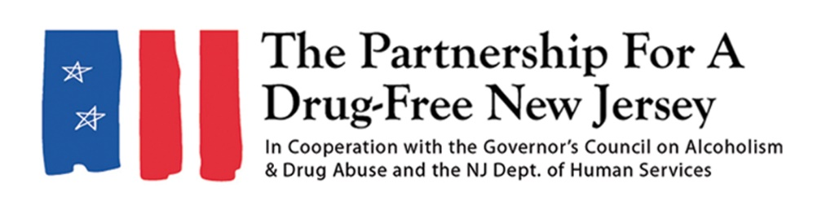Add organization logo
FOR IMMEDIATE RELEASE: DATE
Contact: Matt Birchenough, 201-982-0775, matt@drugfreenj.org
Add Local Contact here
[Name of Town/School/Group/etc.] [Residents/Students/Members] to Knock Out Opioid Abuse
INSERT TOWN — New Jersey residents will mobilize this week [OR A SPECIFIC DAY YOU WILL TAKE ACTION] to do their part to address the opioid epidemic affecting New Jersey as part of the eighth annual statewide Knock Out Opioid Abuse Day.
INSERT LOCAL INFORMATION ON OUTREACH: WHAT WILL YOUR GROUP BE DOING? HOW MANY PEOPLE WILL BE PARTICIPATING
INSERT QUOTE FROM LOCAL ORGANIZER OR LEADER
In its eighth year, Knock Out Opioid Abuse Day educates New Jersey residents on the opioid crisis through a mobilization effort with a dual focus: educating physicians and raising awareness among New Jersey families and communities.
In 2022, nearly 3,000 people in New Jersey died of a drug overdose, a majority of which involved some form of opioid. These deaths include those who overdosed on heroin, prescription opioids and synthetic opioids, such as fentanyl, which now account for a majority of opioid overdose deaths within the state and nationally.
“Knock Out Opioid Abuse Day is an important opportunity to educate New Jersey residents about the opioid epidemic,” said Angelo M. Valente, executive director of the Partnership for a Drug-Free New Jersey. “We are grateful to have so many New Jersey residents ready to be a part of this effort and to take simple, yet meaningful, steps to spread potentially lifesaving information.”
Knock Out Opioid Abuse Day is a project of the Partnership for a Drug-Free New Jersey, in cooperation with the Governor’s Council on Alcoholism and Drug Abuse; the New Jersey Department of Human Services, Division of Addiction Services; and the Community Coalition for a Safe and Healthy Morris, with help from thousands of participants across the state. The New Jersey Senate and General Assembly has supported the event unanimously approving joint legislation designating October 6 as Knock Out Opioid Abuse Day in New Jersey. Governor Phil Murphy signed the resolution in July.
INSERT ANY ADDITIONAL LOCAL INFORMATION ON VOLUNTEERS
Interview and photo opportunities with volunteers regarding their outreach are available.
###
Best known for its statewide substance use prevention advertising campaign, the Partnership for a Drug-Free New Jersey is a private not-for-profit coalition of professionals from the communications, corporate and government communities whose collective mission is to reduce demand for illicit drugs in New Jersey through media communication. To date, more than $200 million in broadcast time and print space has been donated to the Partnership’s New Jersey campaign, making it the largest public service advertising campaign in New Jersey’s history. Since its inception, the Partnership has garnered 211 advertising and public relations awards from national, regional and statewide media organizations.

