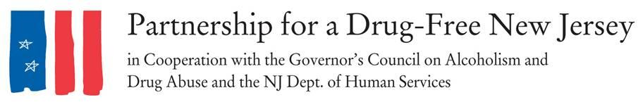  
Contact: INSERT LOCAL CONTACT

Angela Conover, 201-916-1030, [conover@drugfreenj.org](mailto:conover@drugfreenj.org)

David Philemon, 973-467-2100, ext. 24 [media@drugfreenj.org](mailto:media@drugfreenj.org)

**\*\*\*\*MEDIA ADVISORY\*\*\*\***

**Every day pharmaceutical representatives visit INSERT LOCAL TOWN/COUNTY prescribers, on October 6th they will be joined by NJ Parents Who Lost a Child to the Opiate Abuse Epidemic and over 2,000 Advocates from Across NJ to Raise Awareness and Share the CDC Guidelines.**

**WHAT: On October 6, 2016, Knock Out Opiate Abuse Day, New Jersey legislators, concerned citizens INSERT LOCAL TOWN/COUNTY, impacted families, and substance abuse professionals will be joined by two former governors as they take to the streets and physician and dentist offices to raise awareness about the epidemic of opiate abuse that is impacting our state and to raise awareness about the link between prescribed opiates and the heroin abuse rates in New Jersey.**

The statewide single-day initiative will mobilize families, the prevention and treatment communities, community leaders, and concerned citizens to raise awareness of the potential for dependency on prescribed pain medicine and its link to heroin abuse rates in our state. The mobilization will have a dual focus: educating physicians and raising awareness among New Jersey citizens and families.

**Engaging Physicians**

Teams of volunteers across the state will visit physician and dental offices in their community. Volunteers will be equipped with information, including a “door knocker” PSA and a copy of the CDC guidelines for prescribing, to provide each prescriber. This is deigned to raise awareness of the opioid abuse epidemic facing New Jersey and the steps they can take to stem the epidemic. Focus will be place on the following action steps:

* Encourage prescribers to discuss the dangers of opioids when they are prescribed, including the risk of dependency and possible alternatives that may exist.
* Share copies of the Centers for Disease Control and Prevention opioid prescribing guidelines to each prescriber visited and encourage prescribers to implement these guidelines in their own prescribing.
* Provide information on local organizations and resources focusing the opioid abuse epidemic for physicians to share with their patients.

**Engaging Families and The Community**

Teams of volunteers will be mobilized to blanket their community with “Door Knockers” hang tags for the front doors of local homes. These door knob sign will contain an opioid abuse prevention public service announcement with information on the link between prescribed opiates and heroin abuse.

**WHEN:**  **October 6, 2016**, between 10 am and 3 pm.

**WHERE:** In communities across New Jersey. See attached list for participating municipalities.

**Interview and photo opportunities to follow a volunteers in their outreach to prescribers and throughout the community are available.**

**###**